

MOHD. RAZIA
Sai Snehith
2520090149
CS&IT
CO-3

Case Study Topic: Content Recommendation Network Analysis using BFS and DFS in MediaVault
MediaVault recommends related content based on user viewing patterns. Efficient traversal of content relationships is required to identify recommended content. BFS and DFS algorithms were implemented to traverse the recommendation network efficiently.

Problem Statement

The MediaVault system maintains relationships between different content items. Efficient traversal is required to generate recommendations and discover related content.
The challenge is to:
- Traverse content networks efficiently.
- Discover related content.
- Improve recommendation accuracy.
- Support content analytics.
- .
Proposed Solution

Graph traversal algorithms BFS and DFS are used to analyze content relationships.
Implementation Details:

Algorithms Used

Breadth First Search (BFS)

Depth First Search (DFS)

Operations Performed

Create content relationship graph.

Traverse graph using BFS.

Traverse graph using DFS.

Display traversal order.

Analyze recommendation network.

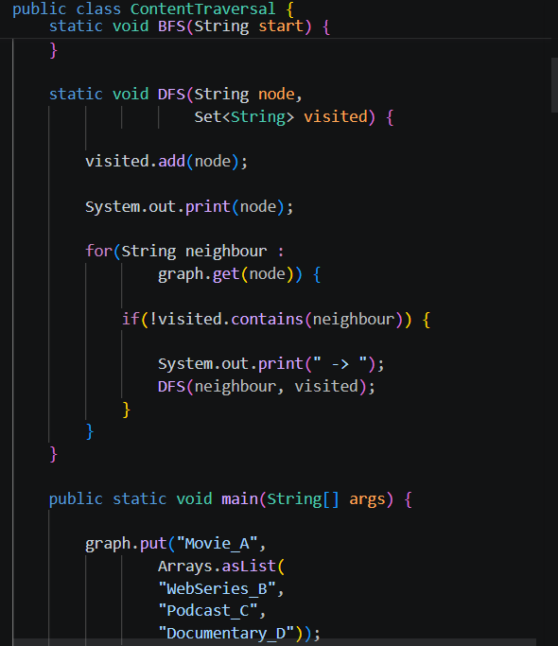

Result: Screenshots/Output

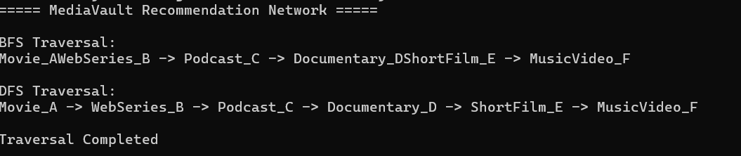

- BFS successfully traversed content level-wise.
- DFS successfully explored content relationships.
- Recommendation discovery became efficient.
- Content network analysis improved.
GitHub Link:

https://github.com/snehiths399-byte/MediaVault--Digital-content-streaming-and-Analytics-system

